Converting pandas dataframe to pyspark dataframe:

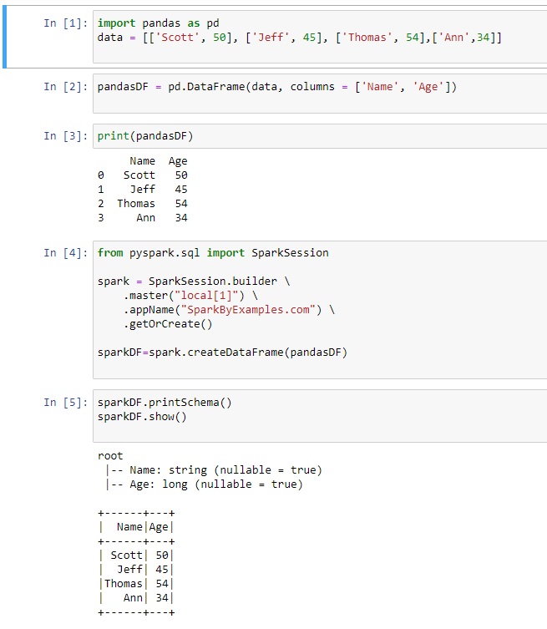

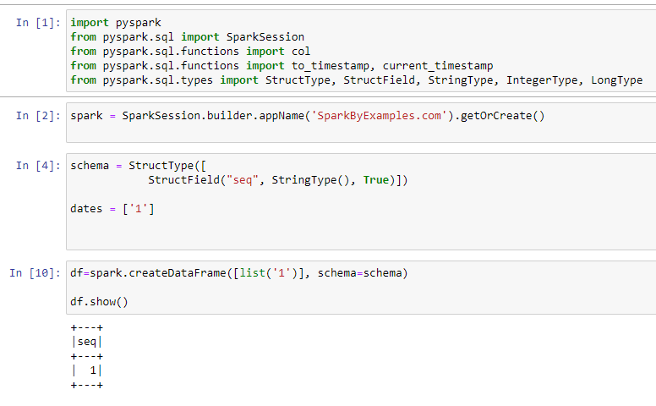

Creating tables :

To create tables from dataframe we should use

Dataframe.createOrReplace TempView(“table”)

Then perform sql operations on it.

Aggregate:

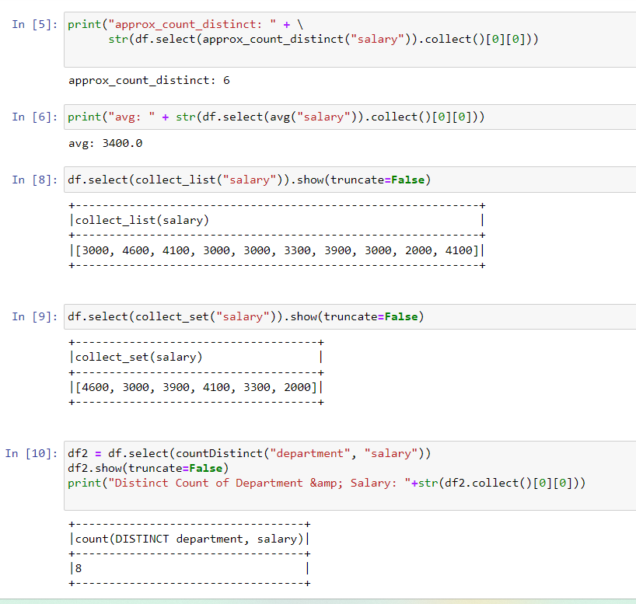

Converting lists to dataframes and rdd:

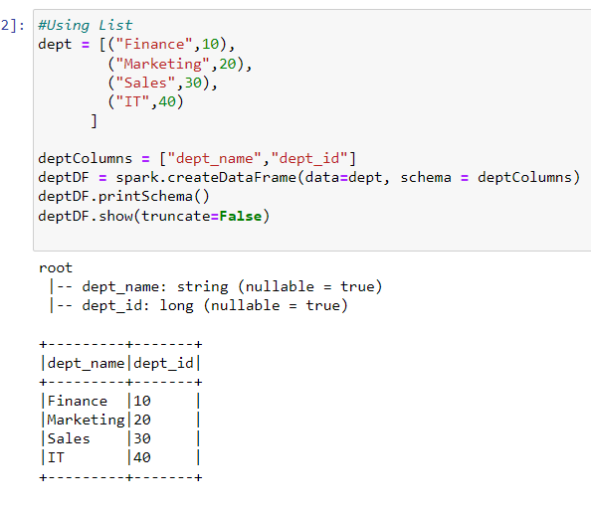

Window functions:

Original Data:

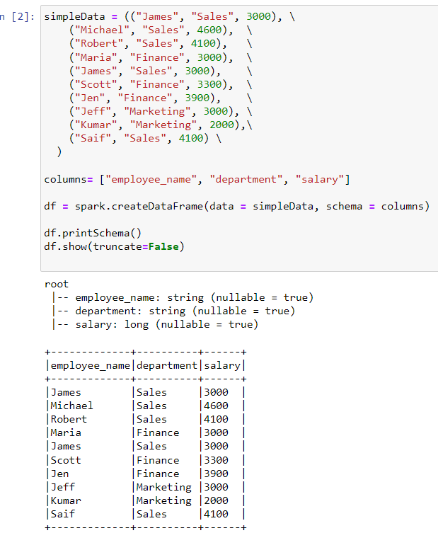

After performing using rownumber partitions ;

It arranges the data department wise orderby salary and gives rownumber to each department people.

Rank:

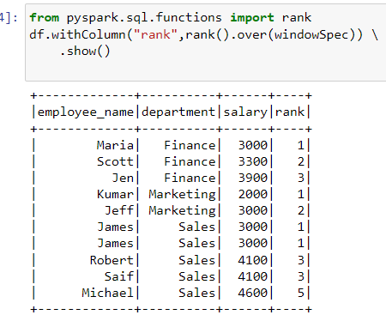

Denserank:

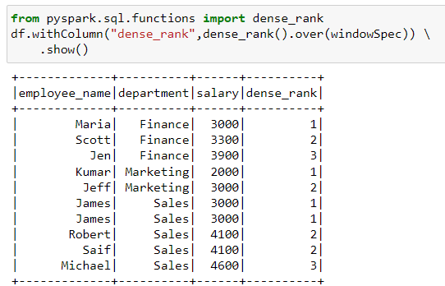

The **LAG()** window function facilitates access to previous rows based on the offset argument. It can be particularly useful when a comparison of a previous value is necessary without the use of a self join. There is a similarity to the LEAD() function with the difference being the accessible rows. LEAD() accesses subsequent rows while LAG() accesses previous rows

When otherwise:

